The Scottish Network for Religion & Literature

In conversation with…

Rodge Glass & Sorcha Dallas
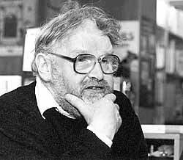
© Günter Prust. Alasdair_Gray_(1994)_by_Guenter_Prust.jpg

  - Alasdair Gray’s biographer & the custodian of his archive discuss religious themes in Gray’s work
12 February 2020 5.30 – 6.30pm
The Senate Room, New College, The Mound, University of Edinburgh

